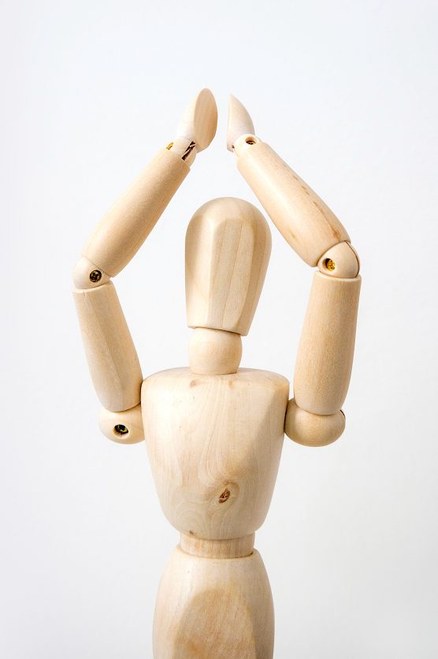
For this activity, you’ll need to work with a partner, so the first thing to do is find a friend!
Together, count from 1 up to 20, clapping on each number. When you clap on a number in the two times table, clap more loudly and say the number more loudly. Clap and speak quietly on the other numbers.
Now clap the five times table together up to about 30, so this time you are clapping more loudly and speaking loudly on the numbers in the five time table and quietly on the others.
If one of you claps the twos in this way and one of you claps the fives, at the same time, can you predict what you would hear?
Which numbers would be quiet?
Which numbers would be fairly loud and which would be very loud?
Now try it - what did you hear?
Were you right?
Choose another pair of tables and repeat what you have just done.
How about the twos and tens?
What about the fives and tens?
Each time, predict what you will hear before you clap - which numbers will be loud, which fairly loud and which quiet?

